Insert your title here
Select "Full Paper" or "Extended Abstract", write it here

Author 1 · Author 2 · Author 3

Abstract This paper considers describes something of relevance to CASPT 2022 or Transit Data 2022.
Keywords: Public transport · Computers · Data

1 Introduction

This is where I might introduce the basic topic and why it is relevant and important to the conference. I may also wish to cite Famous Person (2015) and Lucky Graduate Student et al. (2017) for their insightful contributions to this topic area.

2 Problem Description and Model Formulation

2.1 Problem description

We mainly focus on the following problem description, which includes many valuable but questionable assumptions.

2.2 Model formulation

From the great way that we have defined our problem, we can now formulate this problem using several possible empirical, theoretical, or otherwise helpful equations and constructs.

3 Experiments and results

3.1 Problem case study

To test our model, a real-word instance from City X is used. City X has these curious properties that fit my model extremely well. We had to cajole a person at City X to let us use the data to apply our model. The nice feature is that they were already running the software by Famous Software Vendor (2016).

Our data was likewise very interesting. The way that transit operator Y provided the data allowed a far-reaching investigation of operating policy Q.

3.2 Results

According to our experiments, we obtained the following very interesting results, which suggest that public transport could be much better than it is.

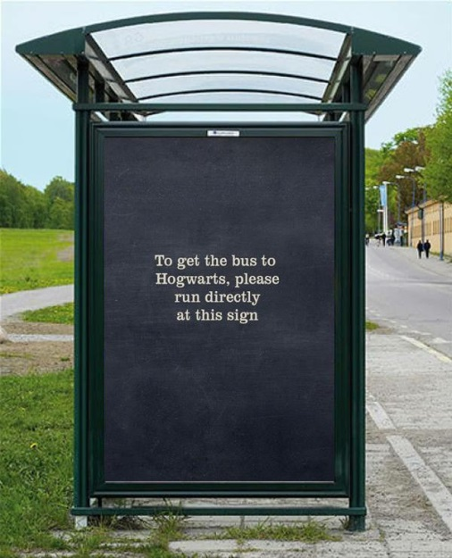
Note also the very fascinating Figure 1, which gives some basic ideas of how these should be formatted. Table 1 also shows how to provide this type of information.

Fig. 1 A new public transport mode is introduced
Table 1 Fascinating Information
Variable | Mean | Variable | Peak Hour Experience
Bus headway | 10 min | Train Services | 30 trains per hour

4 Mathematical Formulas

For the sake of completeness, we also add some mathematical formulas here:

$$a^{2}+b^{2}=c^{2} (1)$$

$$\sum_{i∈I}{X_{i,j}≥1 for all j∈I} (2)$$

$$\sum_{j∈I}{a_{i,j}X_{i,j}≥b_{j} for all i∈I} (3)$$

Please be sure that the equations, figures and tables in your document appear as you wish they would, when you create a PDF of this extended abstract.

Acknowledgements: This research was supported by National Science Foundation of Australia (Grant No. U1234567). We also gratefully acknowledge the data support from Famous Public Transport Operator and the software donated by Famous Software Vendor.

References

Famous Person (2015). An inspiring view of public transport. Transportation Research Part Z: Irreproducible, 28(2), 21-43.
Famous Software Vendor (2016). I liked the demo, version 4.5.
Lucky Graduate Student, Underpaid Postdoctoral Researcher, and Famous Faculty Member (2017). My first published paper. Transport Futures, 6(4), 15-28.

